IS1105

Compiled By: Jin Zhe

NUS

Strategic IT Applications

This set of notes is compiled from Dr. Irene Woon’s lecture slides for AY2012/13 S2. All credits goes to her.

# Information Systems definition

* Combinations of **hardware**, **software**, and **telecommunications networks** that **people** build and use to collect, create and distribute useful **data**
* The term IS is used to represent the field in which people develop, use, manage, and study computer-based information systems

# Organization

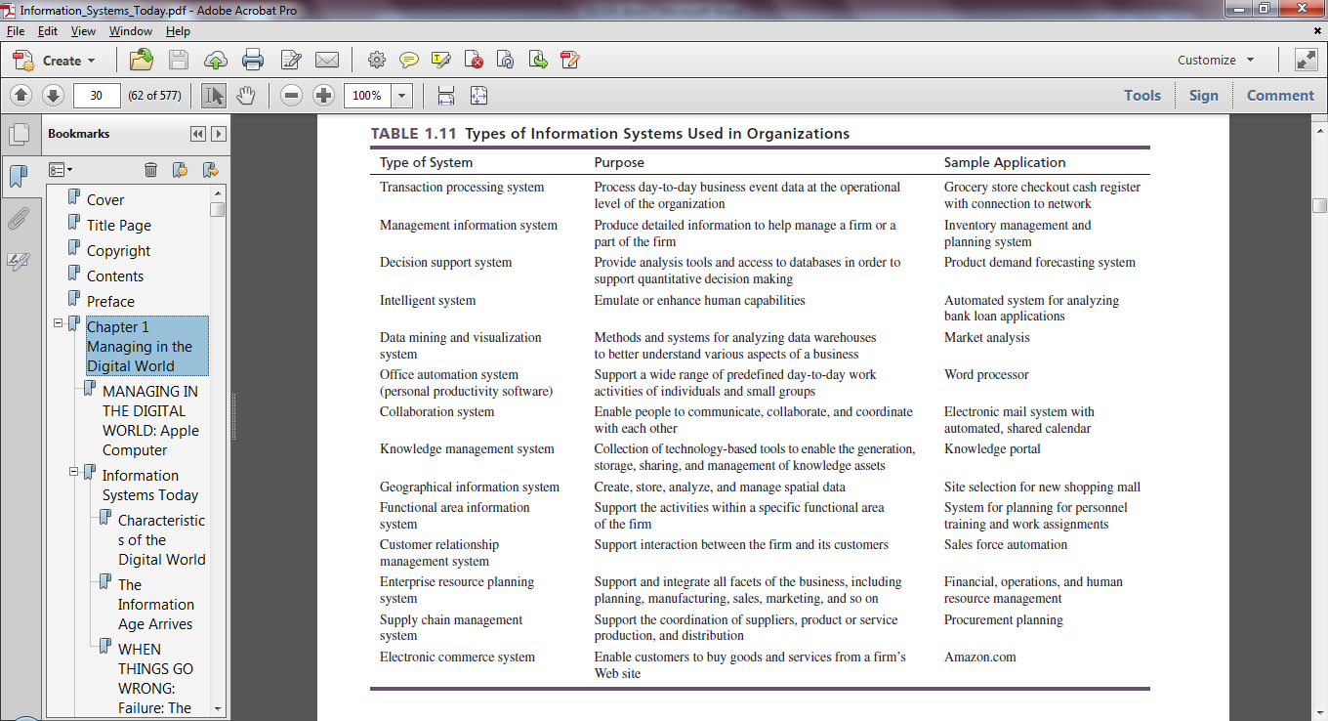

## How IS value-add to Organization

|  |  |  |  |
| --- | --- | --- | --- |
| **What/Where** | **Automation** | **Organizational learning** | **Strategic advantage** |
| **How does IS help** | • Get tasks done faster, cheaper, with greater accuracy and consistency  • Suitable for structured tasks  • Achieves operational level efficiency | • Provides information about its operation and the underlying work it supports  • Support semi-structured and unstructured decision making  • Link and streamline internal and external business processes | • Support generic strategies of cost and differentiation  • Use IS to attain competitiveness  • Identify where to compete via porter’s 5 forces  • Identify how to compete via value-chain analysis |
| **Examples** | Online TPS, Online Exchanges, Mobile Apps, Reverse Auctions, E-Tailing | SCM systems, Data/Test/Web Mining Systems, GIS, CRM, ERP, DSS | Intelligent Systems, DSS, KMS, SCM, CRM, ERP, TPS, Data/Test/Web Mining |

## Organization decision types

**Structured**: Inputs, processing steps, decision rules, and outputs can be precisely defined

**Semi-structured**: Inputs, processing steps, decision rules, and outputs are generally known but some aspects require human judgment

**Unstructured**: Inputs, processing steps, decision rules, and outputs cannot be precisely defined in advance

## Decision-making levels in an Organization and the roles of IS at each level

|  |  |  |  |  |  |
| --- | --- | --- | --- | --- | --- |
|  |  | **Personnel Role** | **Decisions** | **Objective of IS** | **Examples of IS** |
| **Wide Scope** | **Executive level**  Executive-level managers | • Improve organizational strategy and planning | • **Unstructured**  • Complex non-routine problems with long-term ramifications | • **Strategic advantage**  • Obtain aggregate summaries of past organizational data and derives projections of the future  • Provide KPIs across the entire organization | • Executive Information System (EIS) |
|  | **Managerial Level**  Functional managers | • Monitor and control operational-level activities  • Achieve organizational effectiveness: effectively utilize and deploy resources | • **Semi-structured** and moderately complex decisions | • **Organizational learning**  • Provide KPI  • Predictive analysis  • Automate the monitoring and controlling of operational activities | • Management Information System (MIS)  • Decision Support System (DSS)  • Intelligent System |
| **Narrow Scope** | **Operational Level**  Supervisors and foreman | • Monitor and control day-to-day business tasks and activities  • Interactions with customers, suppliers, employees  • Focused on improving organizational efficiency  make structured decisions | • **Structured** and recurring  • Can be automated | • **Automation**  • Automate routine and repetitive activities and events  • Increase productivity | • Transaction Procession System (TPS) |

# Core Business Processes

Most organizations are organized around four distinct functional areas that are responsible for well-defined business functions: marketing and sales, supply chain management, accounting and finance, and human resources. These separate functional areas work together to execute core business processes. These core processes are order-to-cash, procure-to-pay, and make-to-stock/order. Together, these core business processes enable the creation of supply chains that are involved in transforming raw materials into products sold to the end consumer.

## How IS optimize the business process

|  |  |  |  |
| --- | --- | --- | --- |
| **Domain** | **Process** | **Role of IS** | **IS Used** |
| **Internal** | Make-to-stock  Make-to-order | • Improve the flow of information across functional areas within firm | **ERP systems**  • Supports internal core processes  • Provides common database/data warehouse for the entire organization |
| **External** | Procure-to-pay  Order-to-cash | • Enable the better co-ordination of work across different organizations | **CRM systems**  • Integrate and automates customer serving processes |
| **Inter-organizational** | Supply Chain Management | • Improve information visibility, flow and coordination  • Overcome bullwhip effect via tight coupling between all activities in the supply network  • Facilitates Just-in-Time (JIT) and Vendor-Managed Inventory (VMI) | **EDI systems**  • Forms a private industrial network for coordination of trans-organizational business process such as collaborative commerce. E.g. P&G achieves VMI with its suppliers |

Overall, IS results in satisfied customers, good reputation from organization’s responsiveness and reliability.

# Competitive Advantage

## Organizational competitive strategies

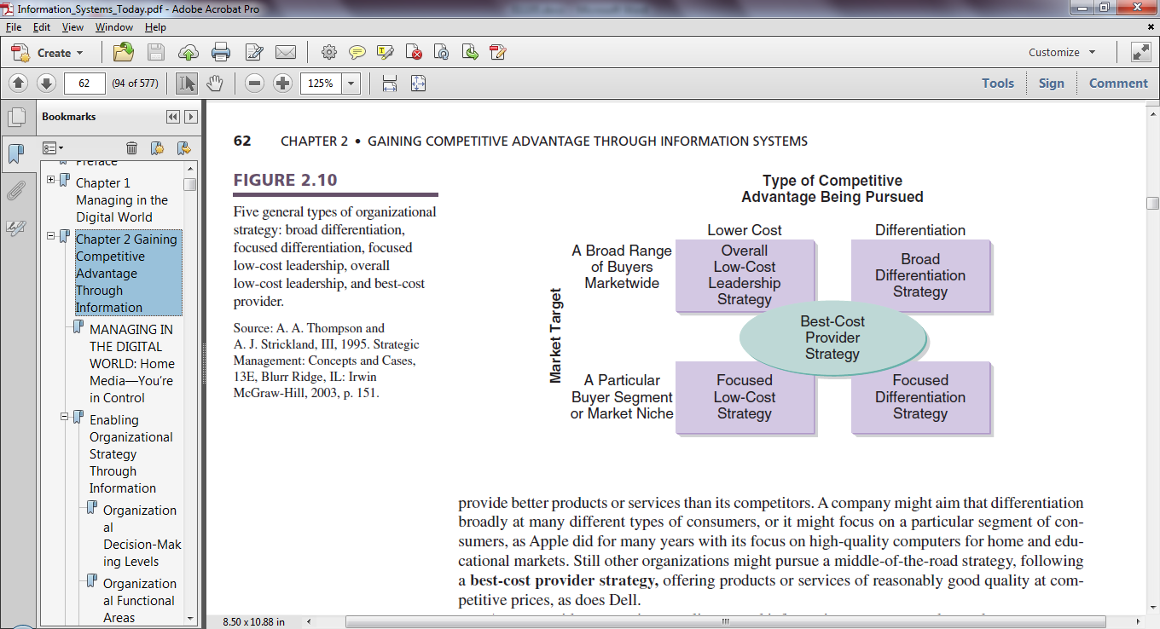

**Cost Leadership**

* Overall lowest-cost in the industry
* Goods are comparable quality at a lower price
* Achieving via IT:
  + Buy from cheaper source
  + Capitalize on EOS
  + Vertical integration either backwards to sources of supply or forwards to end-users of final product
  + Monitor and control every component of firm’s cost

**Differentiation**

* Provide unique products or services
* Can take the form of brand, customer service, quality
* Creates lower sensitivity to price (higher price is justified by unique values offered to customers)
* Achieving via IT:
  + Technical superiority (proprietary technology)
  + Better design and performance
  + Better customer services
  + Quality/reliability

**Market Focus**

* Focus on a particular buyer segment or market niche, out-competing rivals on lower cost or customized needs

**Best Cost Provider**

* Give customers more value for money by combining emphasis on upscale differentiation
* Appeals to the growing middle-class

## Sources of competitive advantage

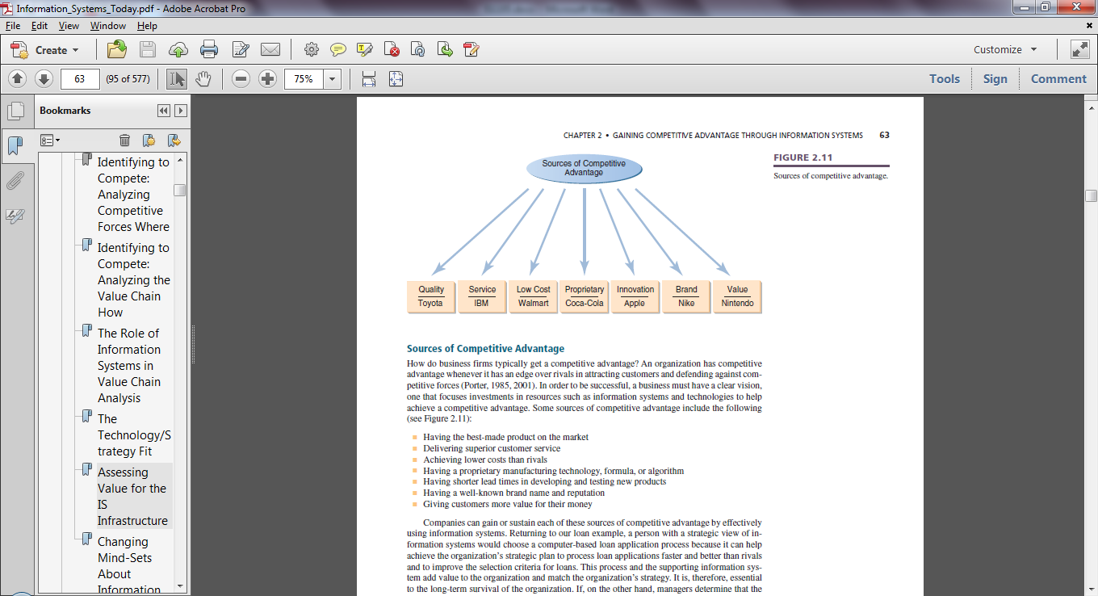

Some sources of competitive advantage:

* **Quality:** Having the best-made product on the market
* **Service:** Delivering superior customer service
* **Low Cost:** Achieving lower costs than rivals
* **Proprietary:** Having a proprietary manufacturing technology, formula, or algorithm
* **Innovation:** Having shorter lead times in developing and testing new products
* **Brand:** Having a well-known brand name and reputation
* **Value:** Giving customers more value for their money

## Identifying *where* to compete: analyzing competitive forces

The 5 forces help the business to decide which industry to compete in since the strength of the 5 forces determines how much profit it can make 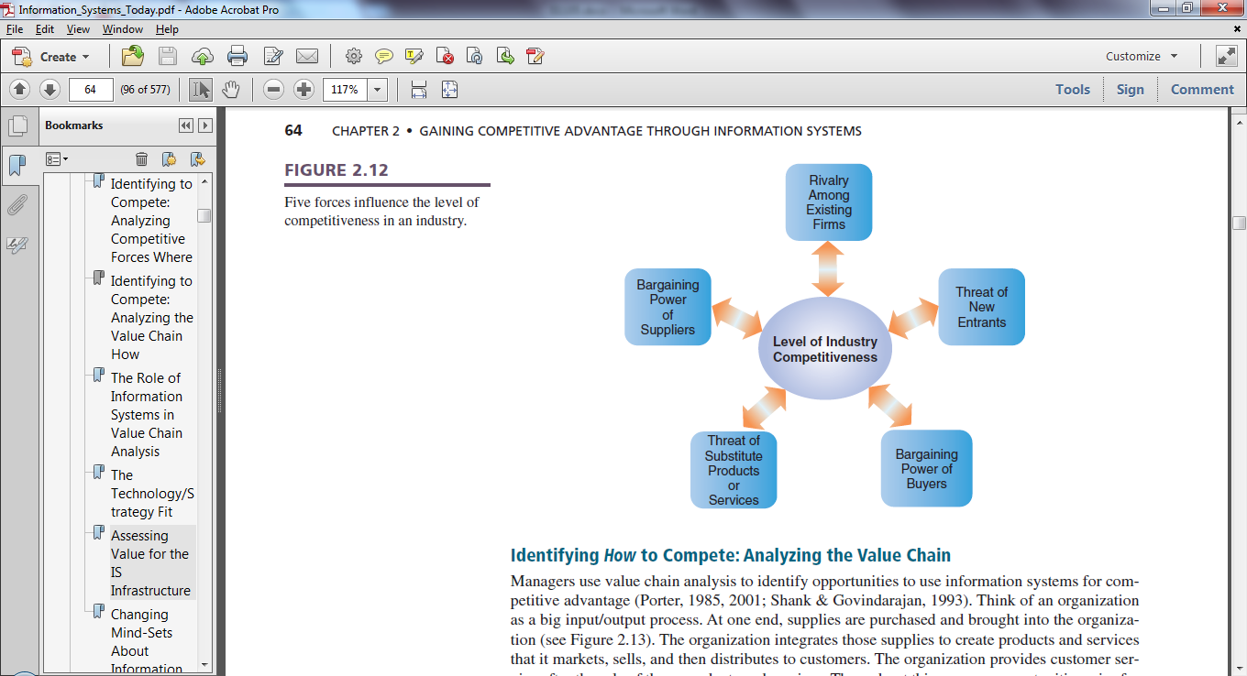

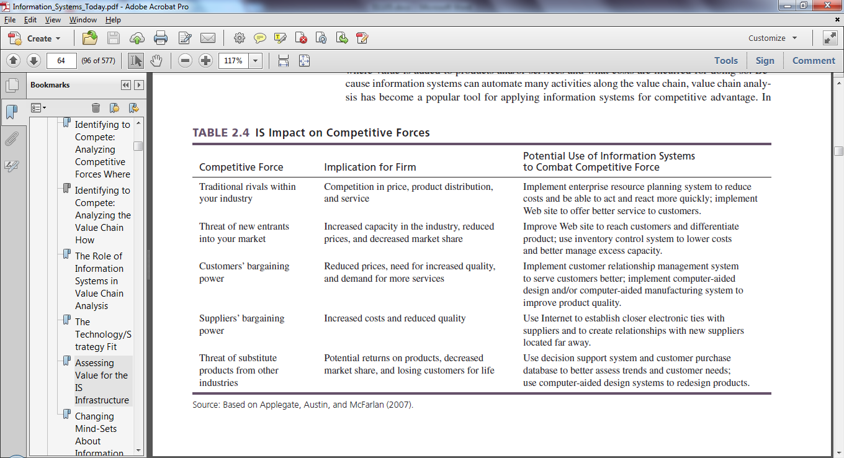

## Identifying *how* to compete: analyzing the value chain

|  |  |  |  |  |  |
| --- | --- | --- | --- | --- | --- |
| **Administration** | The processes and decision making to orchestrate the day-to-day operations of an organization, particularly those processes that span organizational functions and levels. Administration includes systems and processes from virtually all functional areas—accounting, finance, marketing, operations, and so on—as well as  both the executive and the managerial level | | | | |
| **Firm Infrastructure** | The hardware and software that must be implemented  to support the applications that the primary activities use | | | | |
| **Human Resources**  **Management** | The business activities associated with employee management, such as hiring, interview scheduling, payroll, and benefits management | | | | |
| **Technology**  **Development** | The design and development of applications that support the primary business activities | | | | |
| **Procurement** | The purchasing of goods and services that are required as inputs to the primary activities | | | | |
|  | • The business activities associated with receiving and stocking raw materials, parts, and products  • A crucial part of the procure-to-pay business process, as  these activities enable the company to efficiently and effectively fill customer orders | • Once the components have been stocked in inventory, operations and manufacturing activities transform the inputs into outputs | • Focuses on the distribution of end products within the order-to-cash business process | • The presales activities of the company  • E.g. creation of marketing literature, communication with potential and existing customers, and pricing of  goods and services | • Focuses on the postsales activities • E.g. Customers may have questions  and need help from a customer service representative |
|  | **Inbound Logistics** | **Operations** | **Outbound Logistics** | **Marketing and Sales** | **Service** |

To apply information systems strategically, you must understand the organization’s value chain and be able to identify opportunities in which you can use information systems to make changes or improvements in the value chain to gain or sustain a competitive advantage.

Value-chain analysis to help to identify opportunities that IS can enhance the contribution of each activity/sub-activity

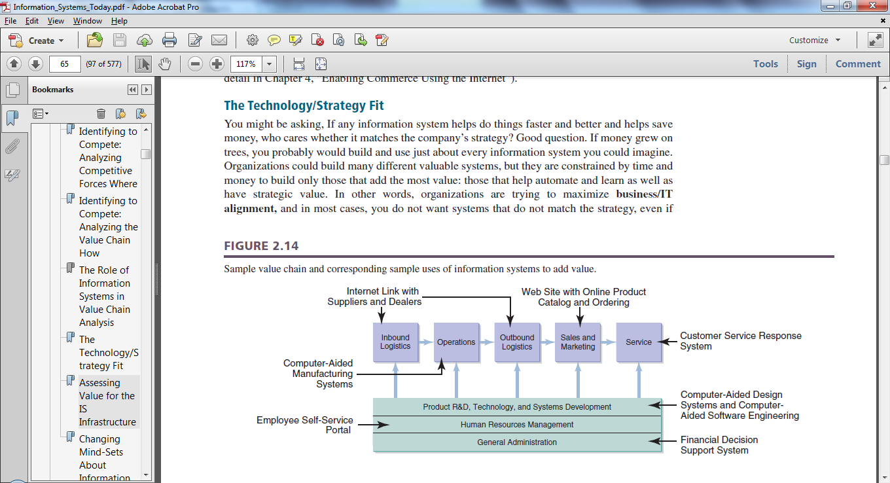

# Business Intelligence

The use of information systems to gather and analyze data and information aggregated from internal and external sources in order to make better business decisions. With these data and information, effective monitoring and fine-tuning of business process could then be conducted.

## Transaction Processing Systems (TPS)

A transaction is an event that transfers product, service or information. Transaction data records the details of the event, the most elementary activity conducted during business operations.

TPS concerns 3 stages:

1. **Data capture and validation**
   1. Manual/automated collection
   2. Basic editing/checking
2. **Data manipulation (Processing)**
   1. Classify, sort, calculate, summarize, store, update, retrieve
   2. Further checking
3. **Producing outputs**
   1. Transaction document/logs
   2. Counts and summary reports
   3. Inputs to other systems

TPS is conducted via 2 approaches:

1. **Online processing**
   1. Done in real-time and therefore offer immediate results
   2. More expensive but provide quick error detection and correction
2. **Batch processing**
   1. Transactions collected and later processed together in batches
   2. Cheaper and more efficient
   3. Used when immediate results are not necessary

## Databases and data warehouses

Databases are collections of related data organized in a way that facilitates data storage, search and retrieval. Data warehouses/data marts integrate multiple databases and other information sources into a single repository to support direct querying, analysis, or processing.

**Spreadsheets from various departments**

**Databases or data warehouses**

**Operational Systems such as TPS**

**Integrates data from 3 sources**

**Business Intelligence**

**Carries 3 components/tools**

**Information visualization**

**Information and knowledge discovery**

**Business Analytics**

## Information and knowledge discovery

Extract information from existing data

**Scheduled reports and Ad-hoc queries**

* Operational systems with conventional files
* Databases with query language such as SQL

**On-Line Analytical Processing (OLAP)**

* Drill down and roll up
* Slice and dice (Analyzing subsets of the dimensions)
  + Analyze relationships between different business elements e.g. sales, profits
  + Compare aggregated data over hierarchical time periods e.g. monthly, quarterly
  + Present data in different perspectives e.g. sales by region e.g. Sales by product within region

**Data-mining**

Tasks:

* Classification: assigns instances to a pre-defined class
* Clusters: Identify natural groupings/structures in the data
* Associations: Predict the occurrence of an item based on occurrences of other items
* Sequential rules: Identify any causal relationships with a certain confidence

Techniques:

* Clustering (identifying natural groupings/structures)
* Text mining: The use of analytical techniques for extracting information from internal and external textual documents
* Web mining
  + Web content mining: use of analytical techniques for extracting information from web documents via web crawlers or web spiders
  + Web usage mining: use of analytical techniques to determine patterns in customers’ web usage data

## Business Analytics (BA)

BA concerns the prediction of future outcomes resulting from business activities. This is achieved through several IS:

**Decision Support Systems (DSS)**

* Supports human semi-structured and unstructured decision-making for recurring problems
* Used mostly by managerial level employees
* What-if analysis: predicts results for hypothetical changes
* Optimization analysis: derive optimal allocation of resources
* Goal seeking analysis: determines problem data required for a given result
* Statistical analysis: Analyze past figures to predict future growth

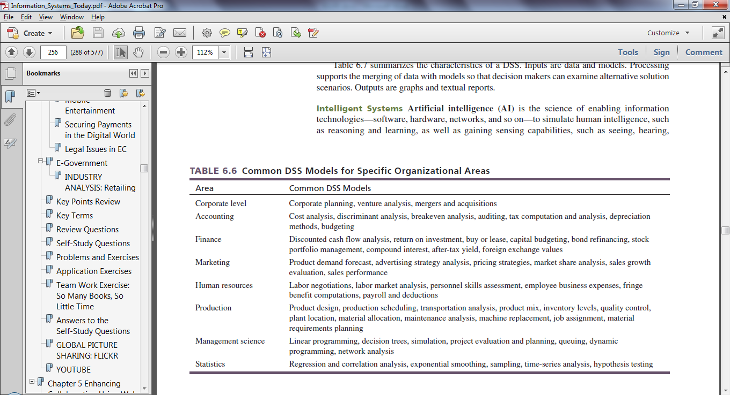

**Intelligent Systems**

Emulate human thinking skills via AI systems

Expert Systems:

* Use reasoning methods
* Provide advices like a human expert
* Manipulate knowledge rather than information
* System asks series of questions and answers using inference/pattern matching and the use of fuzzy logic
* Industrial applications:
  + Forward chaining: Begins with a problem and steps through its resolutions by making decisions about specific steps that could be logically followed
  + Backward chaining: Begins with the solution or present situation and steps backwards through the processes to determine how the issue started

Intelligent Agents (bots)

* E.g. User agents, Buyer agents, Monitoring and sensing agents, Data-mining agents, Web crawlers, Destructive agents

**Knowledge Management Systems (KMS)**

KMS is a repository of organizational knowledge to be used to enhance work performance. Value is generated from the management of knowledge assets.

Knowledge assets falls under two categories:

* Explicit knowledge assets: Can be documented, codified and archived using systems
* Tacit knowledge assets: Difficult to generate, share, codify and archive using systems. They often reflects an organization’s best practices

Implementation issues:

* Huge spending
* KMS does not guarantee success: Difficult to use, implement and enforce usage
* Should be integrated into firm’s operations
* Incentivize usage and compliance

## Information Visualization

Information visualization displays complex data relationships using graphical methods. This is achieved via digital dashboards, visual analytics and Geographic Information Systems (GIS).

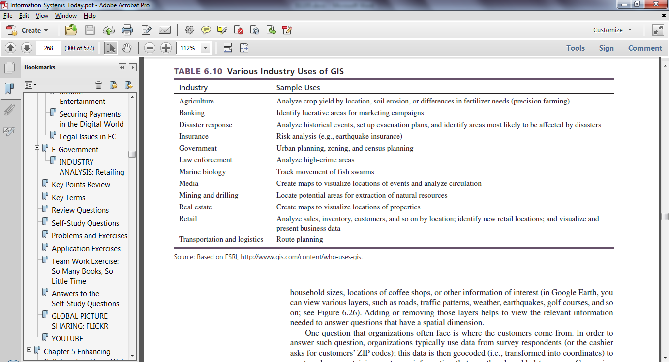

# Enterprise-Level Strategic IS

## Enterprise Systems

Enterprise systems are information systems that span the entire organization and can be used to integrate business processes, activities, and information across all the functional areas of a firm. Enterprise systems can be either prepackaged software or custom-made applications. The implementation of enterprise systems often involves business process management, a systematic, structured improvement approach by all or part of an organization that critically examines, rethinks, and redesigns processes in order to achieve dramatic improvements in one or more performance measures, such as quality, cycle time, or cost. Enterprise systems evolved from legacy systems that supported distinct organizational activities by combining data and applications into a single comprehensive system.

1. **Enterprise Resource Planning (ERP)**. Helps integrate the various data sources and processes of an organization into a unified system
2. **Customer Relationship Management (CRM)**. Helps companies win and retain customers, gain marketing and customer insight, and focus on customers
3. **Product Life Cycle Management**. Helps manufacturers set up a single source for all product-related information necessary for communicating closely with business partners and supporting product lines
4. **Supply Chain Management (SCM)**. Helps companies enhance operational flexibility across global enterprises and provide real-time visibility for customers and suppliers
5. **Supplier Relationship Management**. Allows customers to collaborate closely with suppliers and organize sourcing processes that enhance transparency and lower costs

## Enterprise Resource Planning

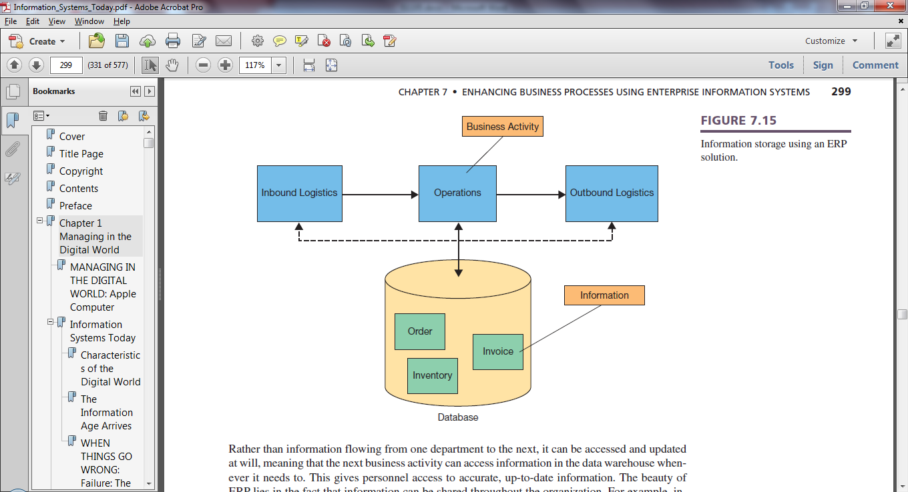

ERP systems allow information to be shared throughout the organization through the use of a large data warehouse, helping to streamline business processes and improve customer service. When selecting an ERP system, organizations must choose which modules to implement from a large menu of options—most organizations adopt only a subset of the available ERP components. ERP core components support the major internal activities of the organization for producing their products and services, while ERP extended components support the primary external activities of the organization for dealing with suppliers and customers.

## Supply Chain Management

SCM focuses on improving interorganizational business processes and has two main objectives: to accelerate product development and to reduce costs associated with procuring raw materials, components, and services from suppliers. Advances in SCM have enabled concepts such as JIT strategies and VMI. At the same time, effectively managing the supply chain has become important to avoid the bullwhip effect, effectively manage quality problems, and pursue sustainable business practices. SCM systems consist of SCP, SCE, and supply chain visibility and analytics components. SCP involves the development of various resource plans to support the, efficient and effective production of goods and services. SCE puts the SCP into motion and reflects the processes involved in improving the collaboration of all members of the supply chain—suppliers, producers, distributors, and customers. SCE involves the management of three key elements of the supply chain: product flow, information flow, and financial flow. Supply chain visibility and analytics help in foreseeing the impacts of external events and monitoring the performance of the supply chain to address performance issues. When developing an SCM strategy, an organization must consider a variety of factors that will affect the efficiency and effectiveness of the supply chain. Specifically, organizations must match their overall supply chain strategy to their overall competitive strategy to reap the greatest benefits. SCM is continuously advancing, using technologies such as XML and RFID.

## Customer Relationship Management

CRM is a corporate-level strategy to create and maintain lasting relationships with customers by concentrating on the downstream information flows through the introduction of reliable systems, processes, and procedures. Applications focusing on downstream information flows have three main objectives: to attract potential customers, to create customer loyalty, and to portray a positive corporate image. To develop a successful CRM strategy, organizations must do more than simply purchase and install CRM software; they must also make changes to policy and business processes, customer service, employee training, and data utilization. A CRM consists of three primary components: operational CRM, analytical CRM, and collaborative CRM. Operational CRM focuses on activities that deal directly with customers and includes modules such as SFA, customer service and support, and EMM. Analytical CRM focuses on activities that aid managers in analyzing the sales and marketing functions as well as in monitoring ongoing conversations in social media. Finally, collaborative CRM provides effective communication capabilities within the organization and externally with customers. When implementing a CRM strategy, organizations have to be sure to carefully consider ethical concerns associated with profiling customers or treating them in ways they may object to.